**SoundScorez UML Design Models**

**Flow 1 Activity Diagram:**

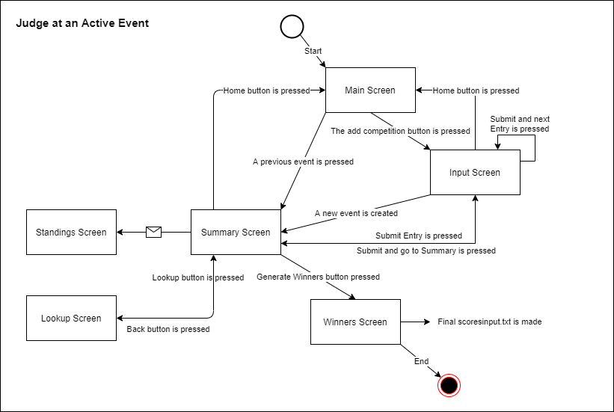

**Flow 1 Sequence Diagram:**

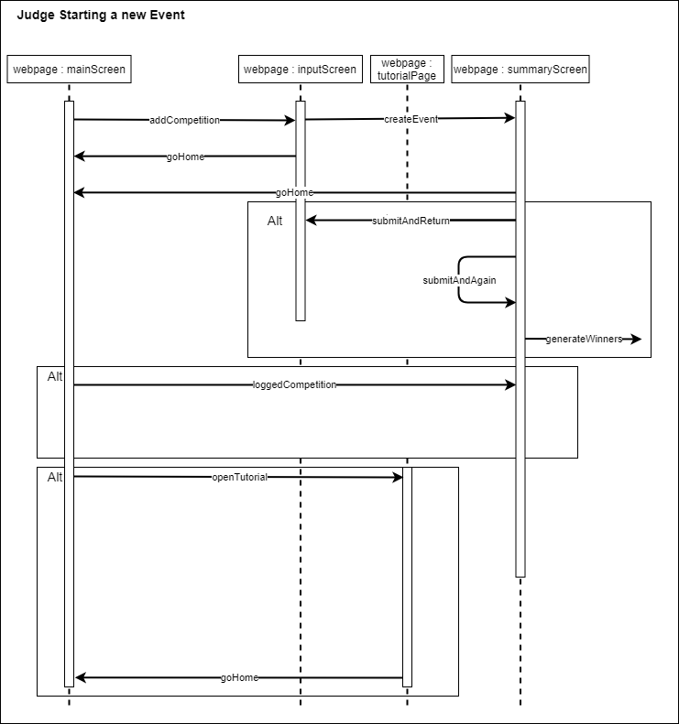

**Flow 2 Activity Diagram:**

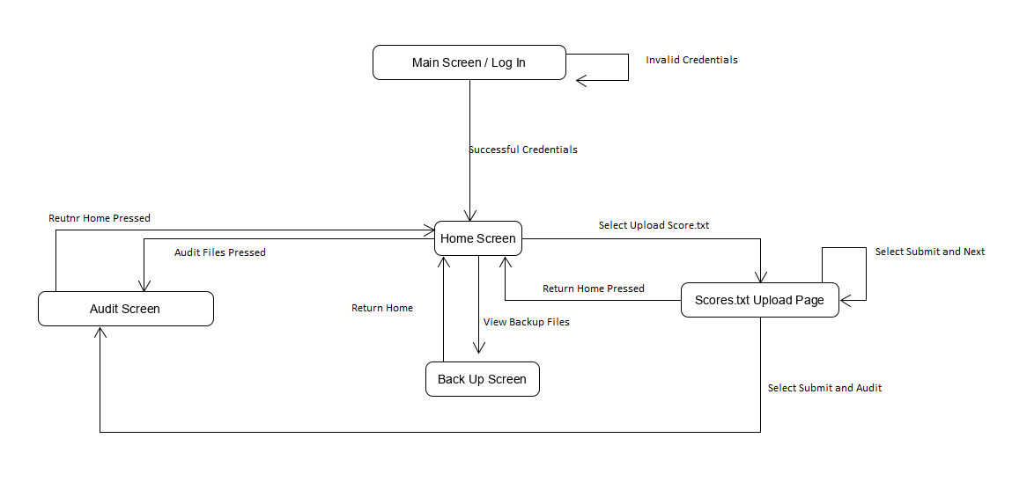

**Flow 2 Sequence Diagram:**

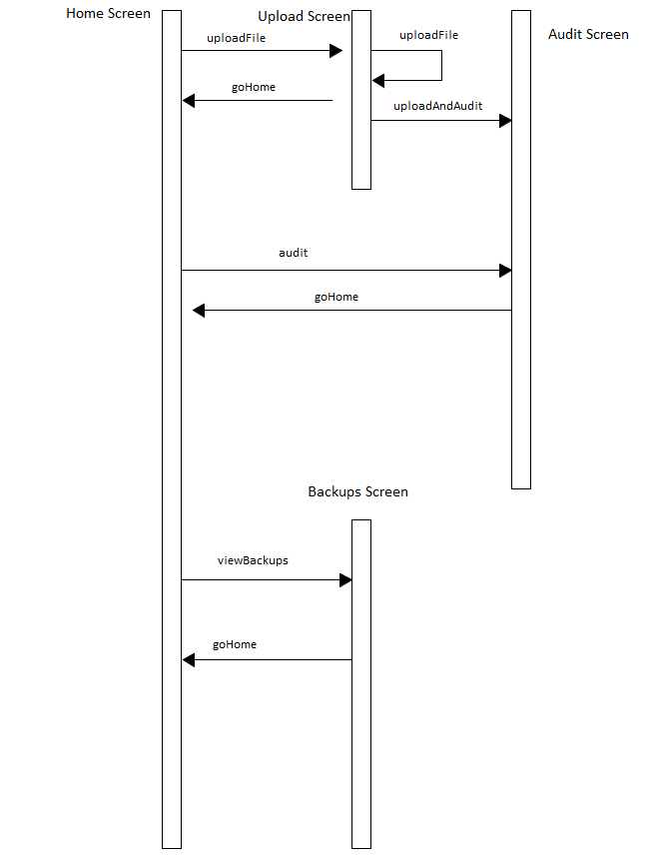

**Main Class Diagram 1:**

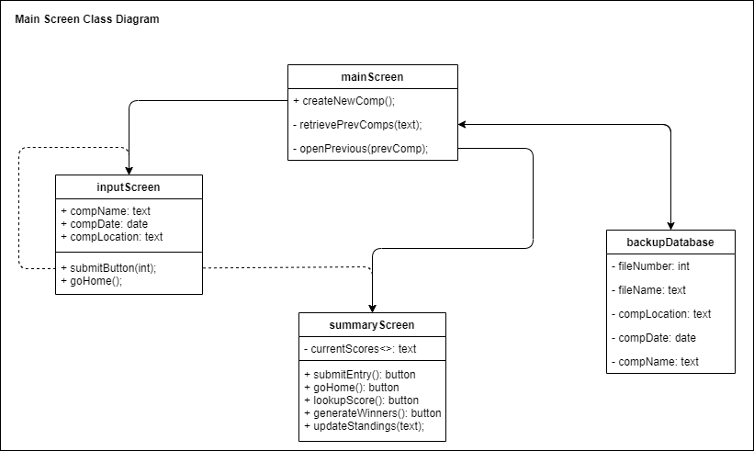

**Main Class Diagram 2:**

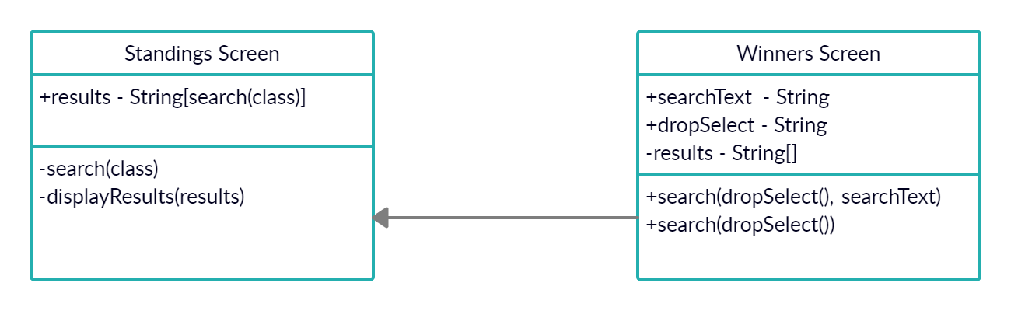

**Use Case Diagram 1:**

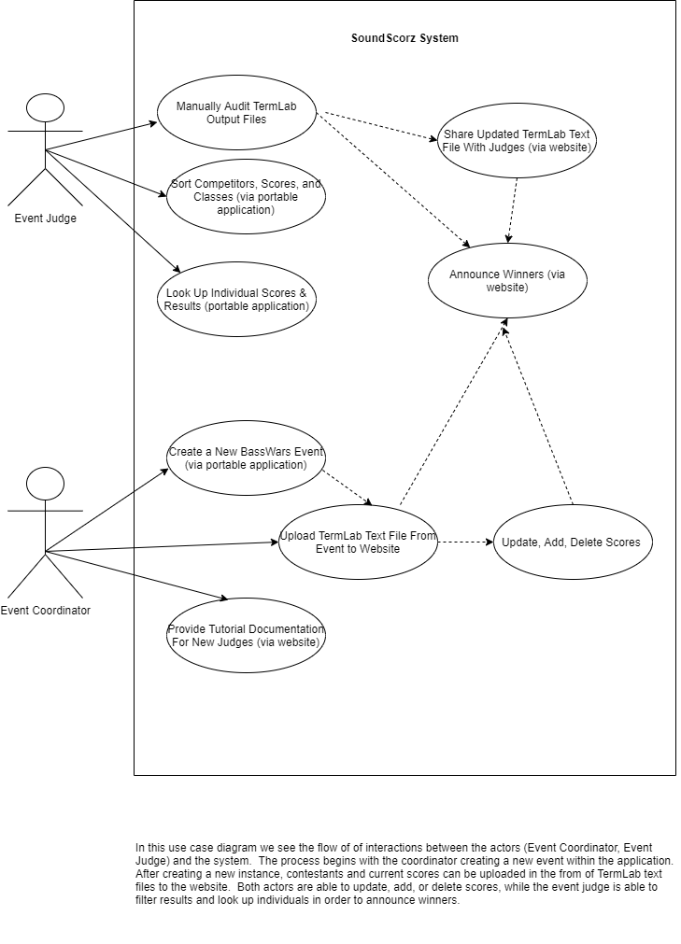

**Use Case Diagram 2:**

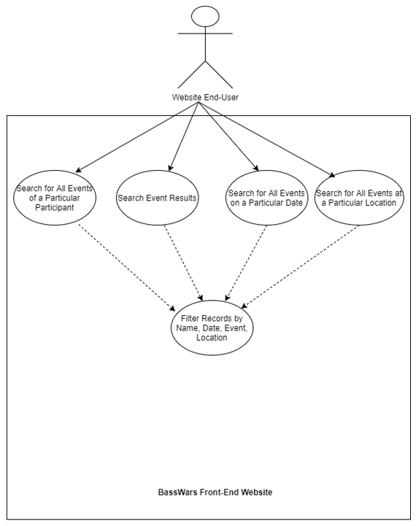

**Use Case Diagram 3:**

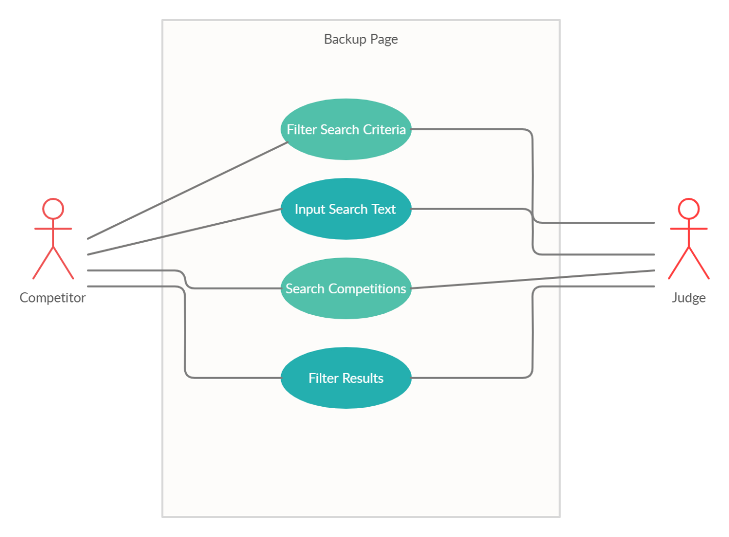

**Use Case Diagram 4:**

